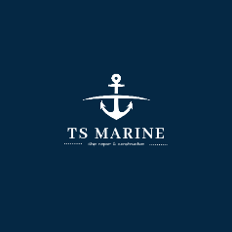
TS Marine Quality Policy
Quality:
Implementation of repair, mechanical and inspection works on hulls of vessels, covers closing cargo holds, dredgers, coolers, valves
of thrusters, main propellers and works on modification, prefabrication and installation of new pipelines.
in a manner consistent with legal requirements and meeting customer requirements.
Our company declares compliance of the IMS with the requirements of the standard:
PN-EN ISO 9001:2015 in full scope,
PN-EN ISO 45001:2018 in full scope.
Maintaining the reputation of a company caring for the health and safety of employees is an important goal of our business.
Every customer is important for us.
OHS
Creating safe and hygienic working conditions - preventing injuries and diseases. Removing threats to health and safety at work
enables efficient performance of the accepted obligations.
We undertake to implement the above declaration by:
• meeting the requirements and continuously improving the effectiveness of the integrated management system,
• meeting legal regulations and requirements concerning the services provided, health and safety
• striving for continuous improvement of the health and safety status,
• selecting reliable partners,
• continuously improving the qualifications and awareness of potential employees,
• encouraging potential employees to participate and get involved,
• full management responsibility for the implementation of the policy and the commitments made,
• providing adequate resources and means to implement this policy.
Everyone in our company is responsible for the quality of services and health and safety.

